**Create two Users (IT admin & Billing Manager) and assign Roles to them accordingly in AWS.**

**Login to AWS console and Go to IAM**

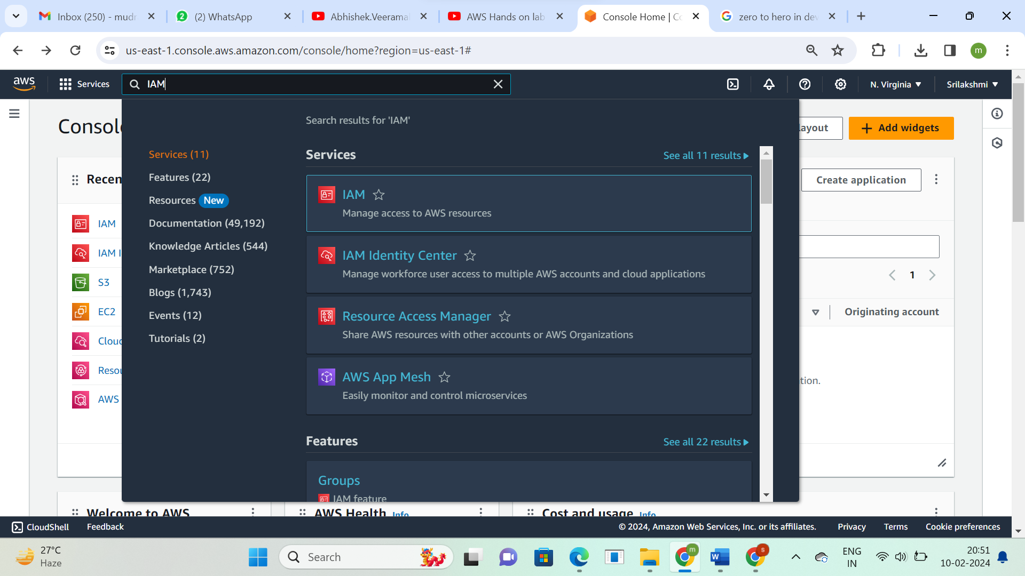

**Create 2 IAM users-IT-admin and Billing-Manager  
Click on create user**

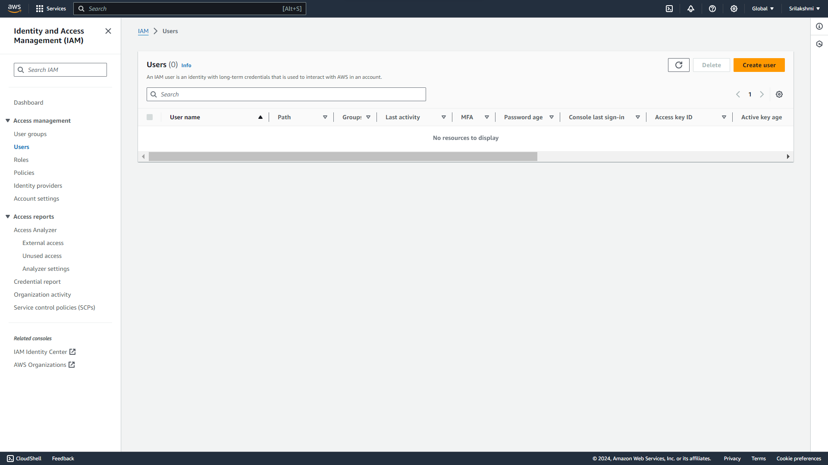

**Create 1st IAM user, user name-IT-admin  
Select custom password and click on next**

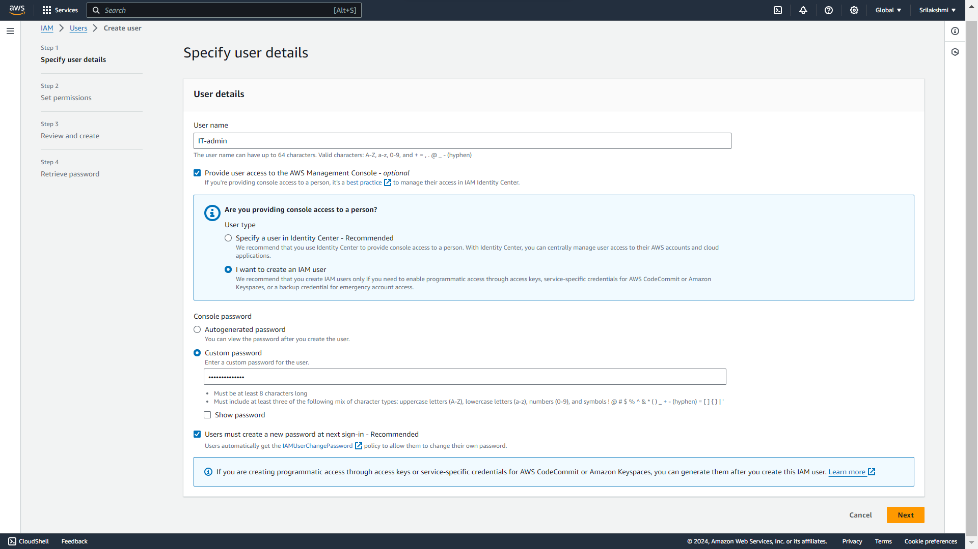  
**Click on attach policies directly   
select permission policy-Administrator access and click on next**

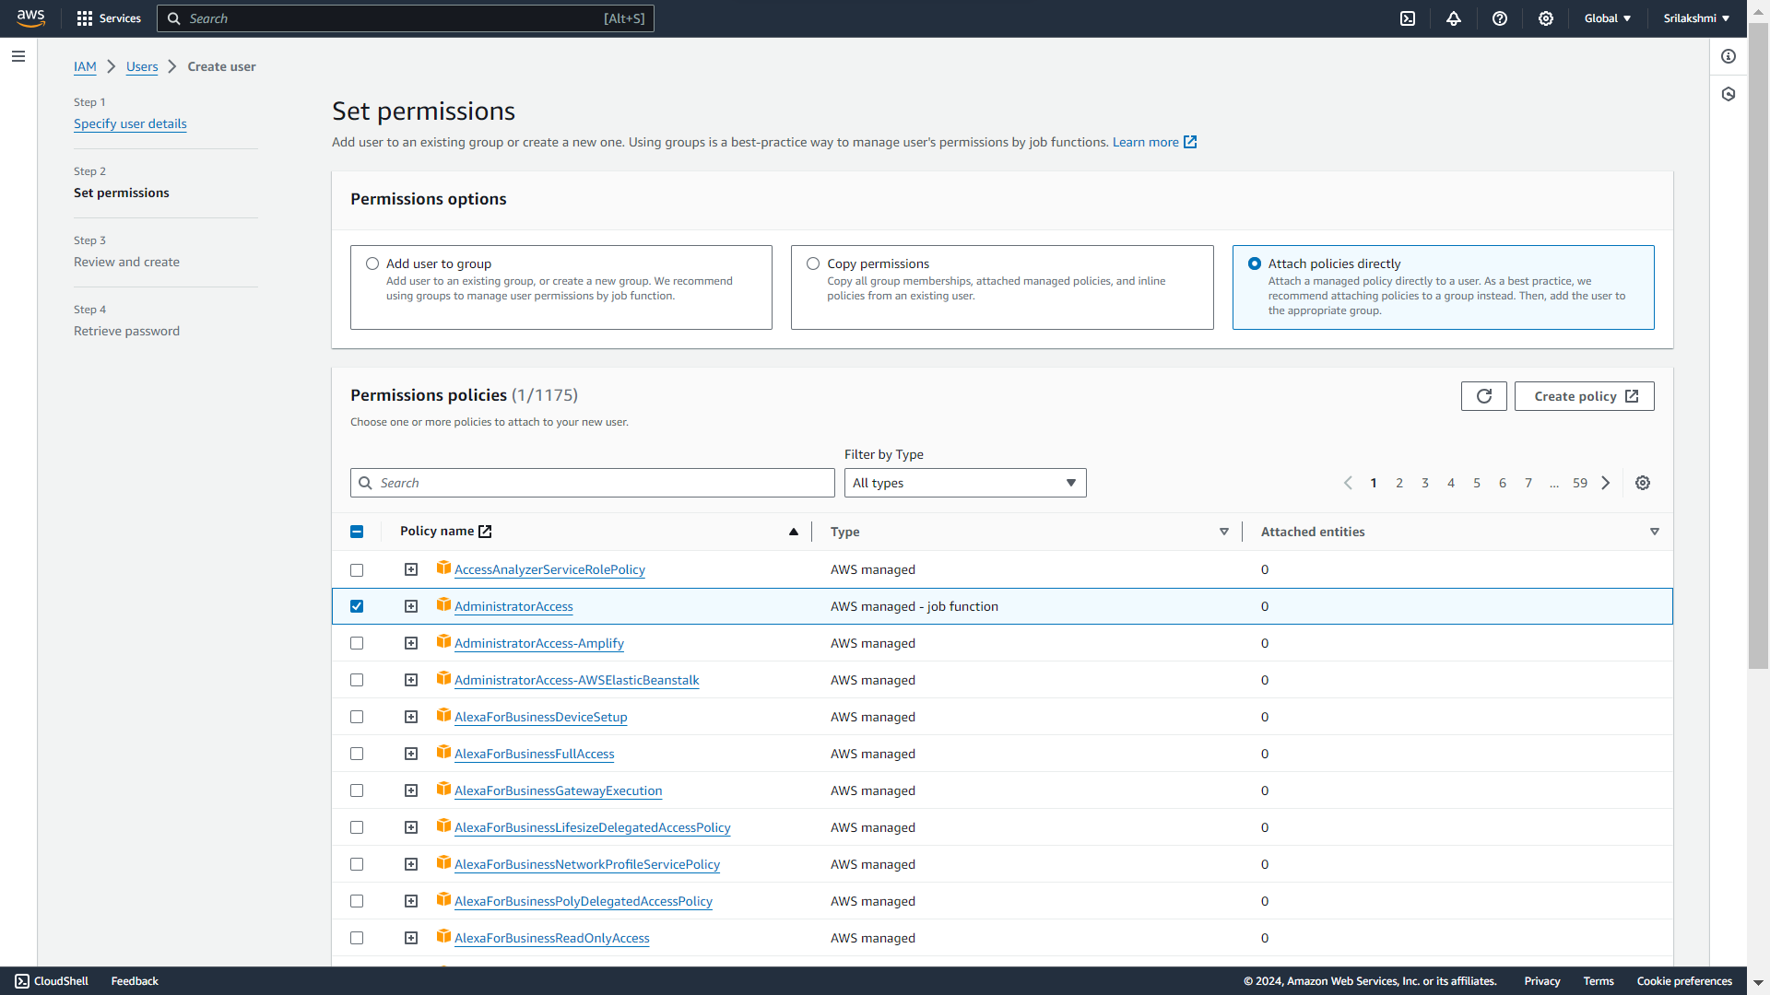

**Review and click on create user**

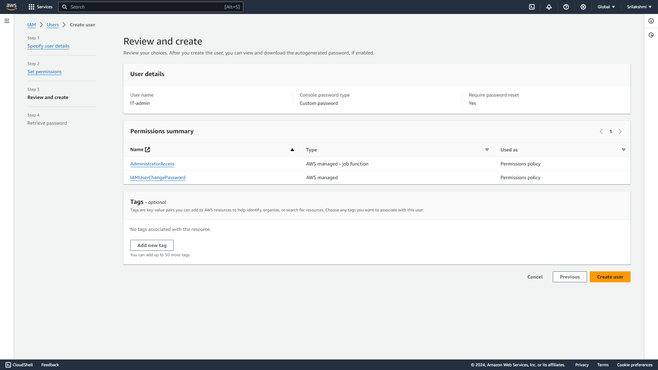

**Download the User details**

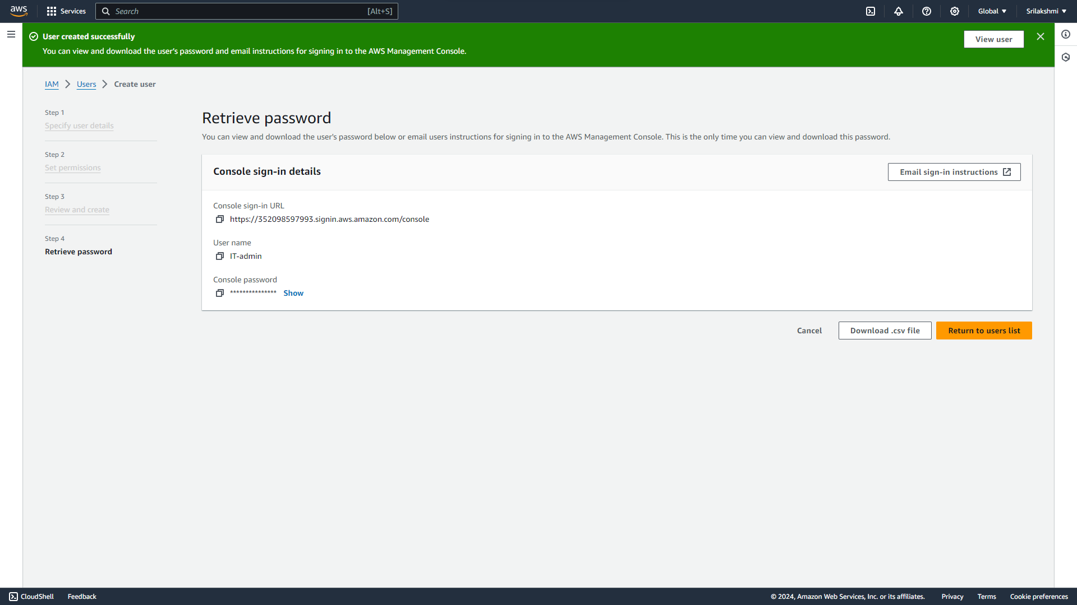

**Create 2nd IAM user, User name-Billing-Manager**  
**Select custom password and click on next**

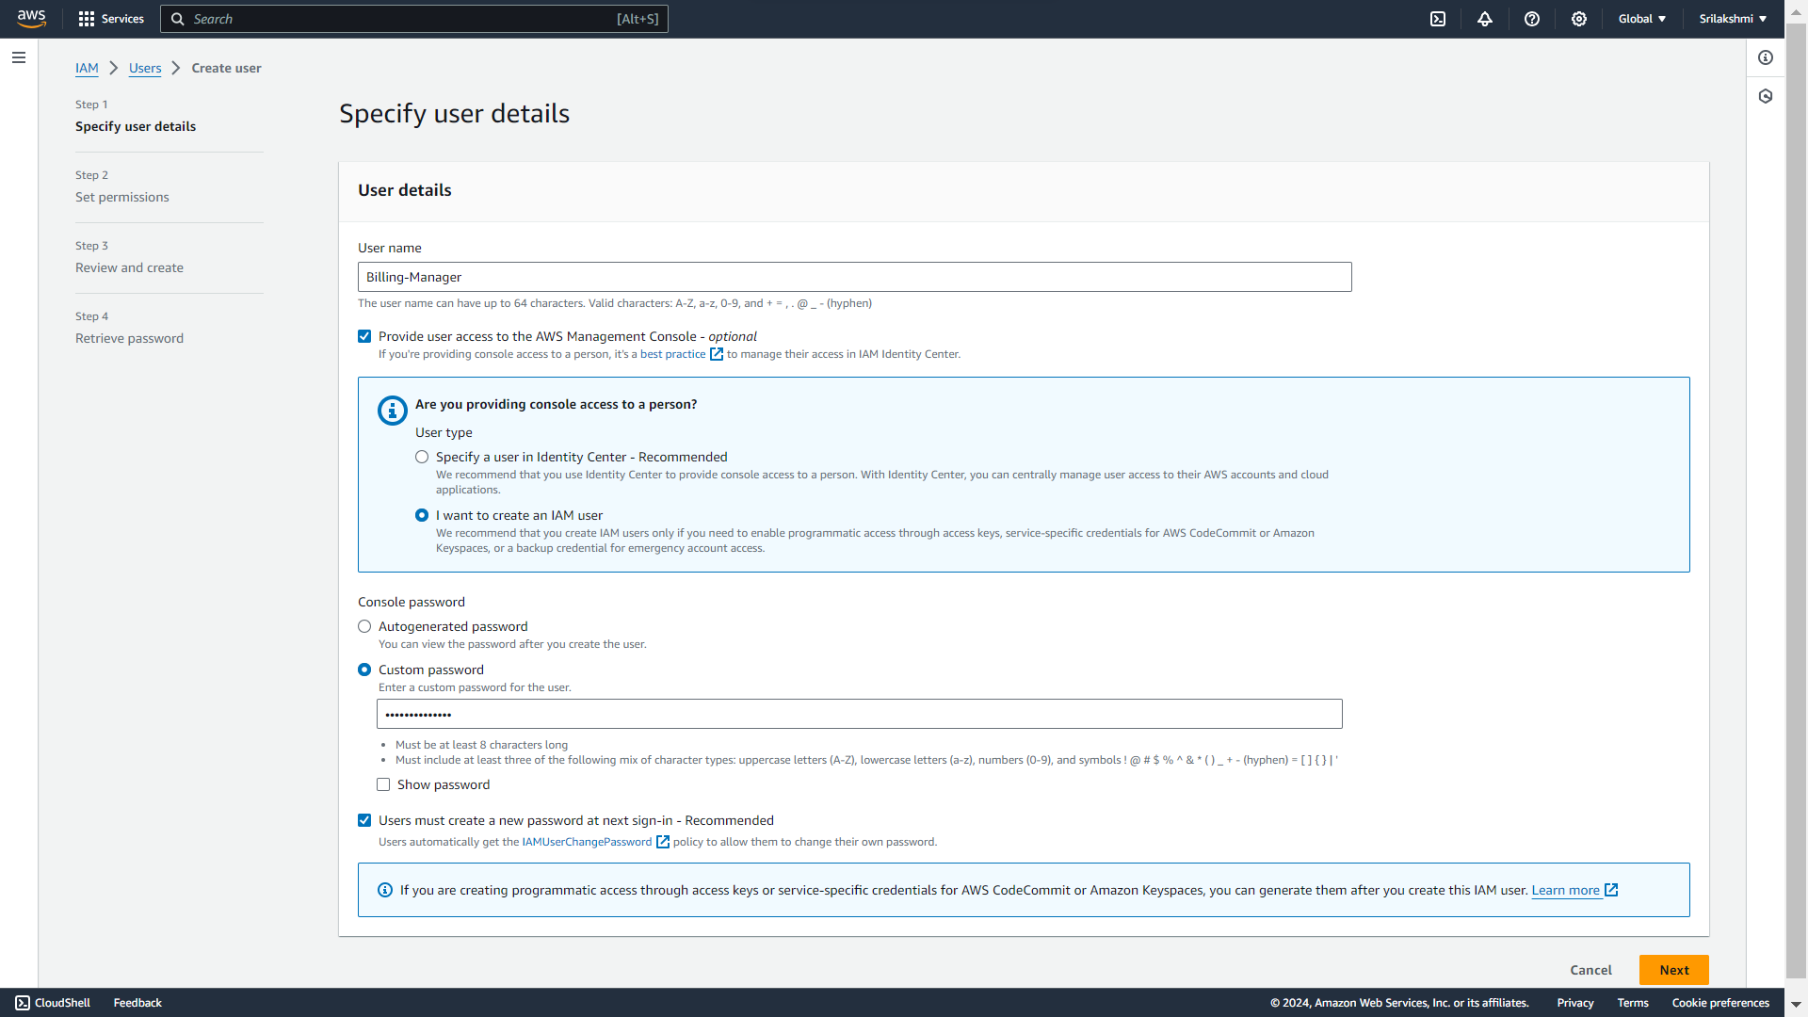

**Click on attach policies directly   
select permission policy-Administrator access, Billing and click on next**

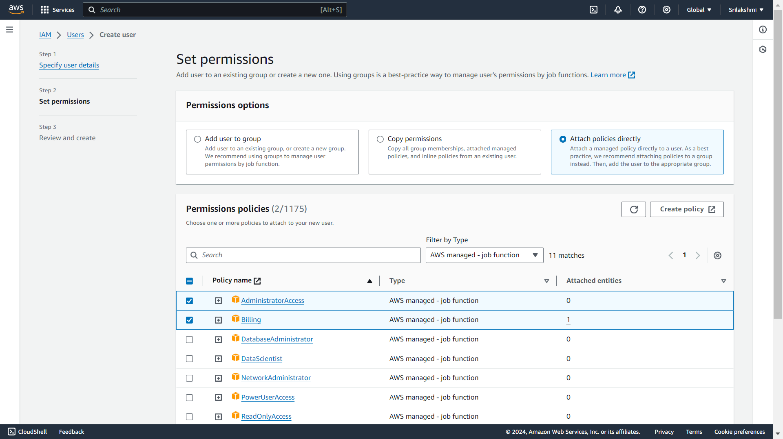  
**Review and click on create user**

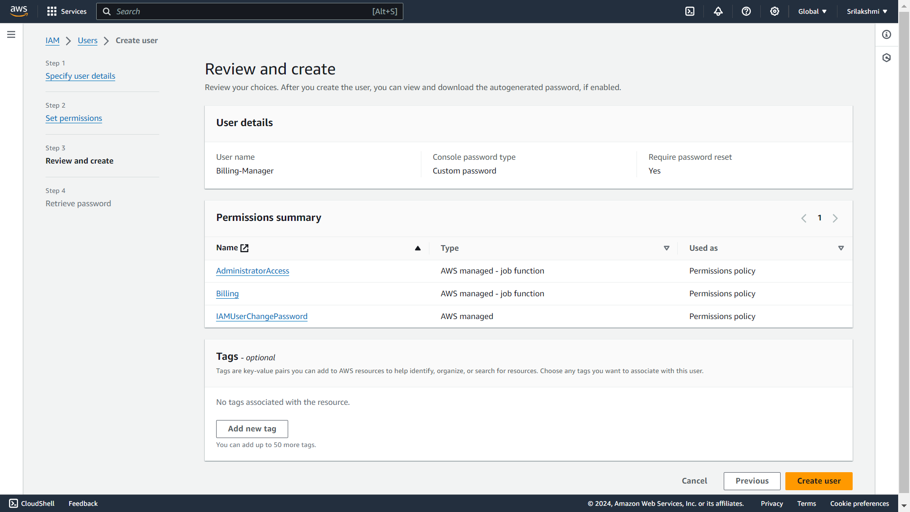

**Download the user details**

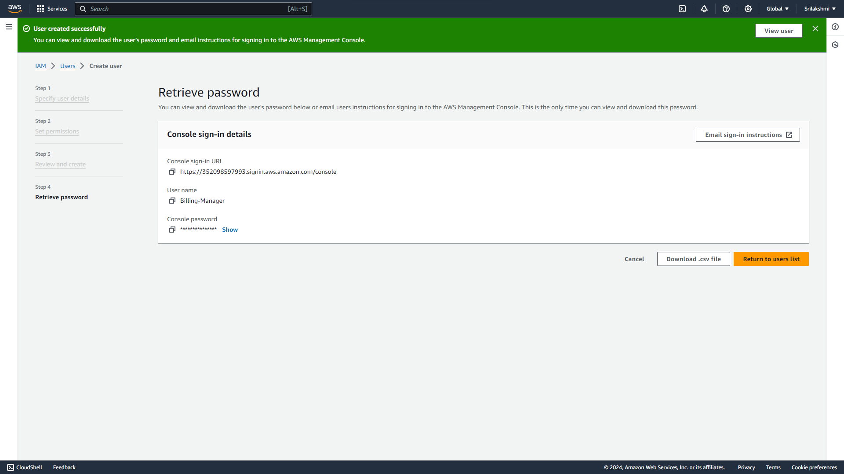

**Login to the 2IAM user accounts and assign roles with policies**

**Go to AWS console and click on IAM user and login with the 1st IAM user-IT-admin  
User name and password**

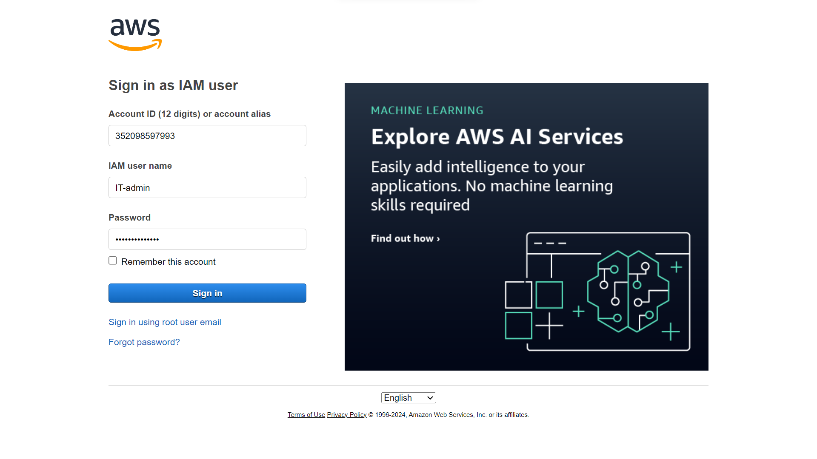  
**Assign role for the 1st IAM user-IT-admin along with the policy  
Go to IAM and click on create role**

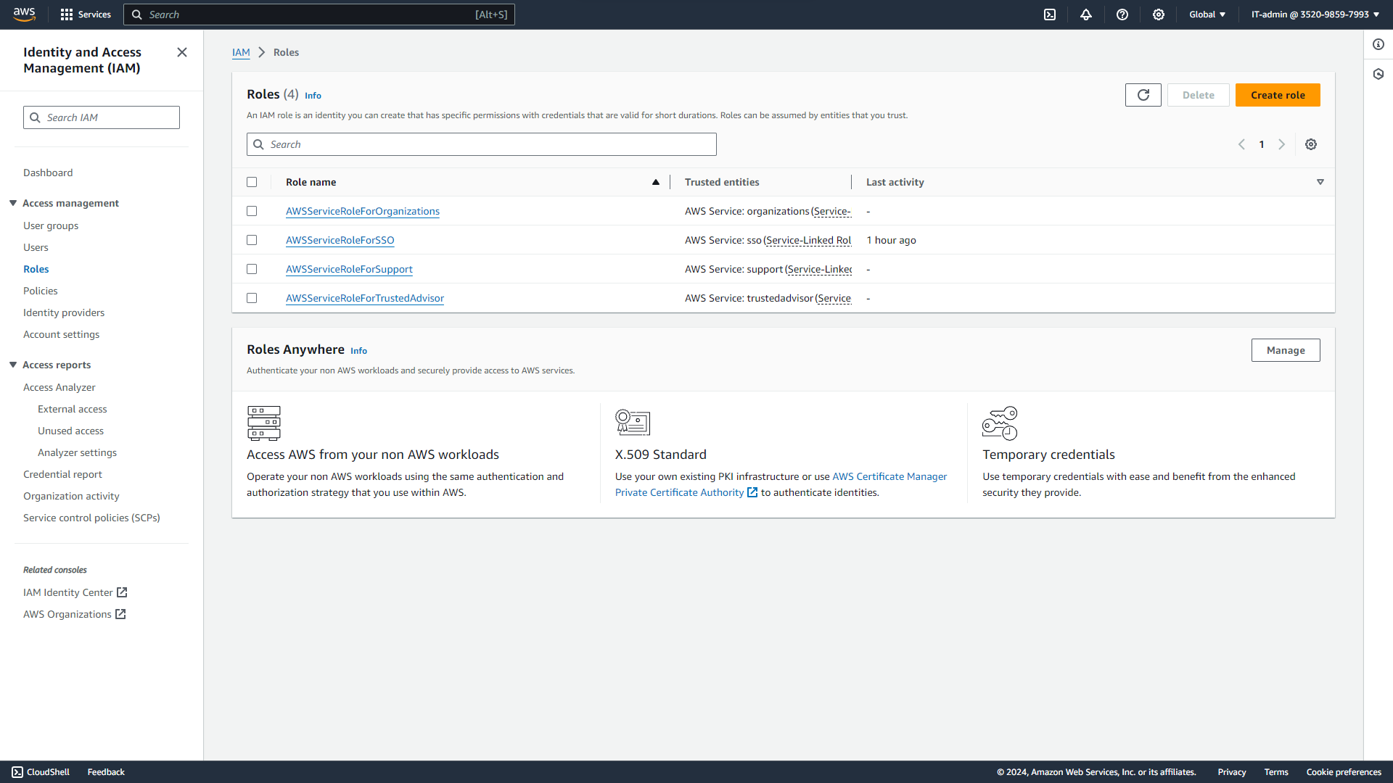

**Select AWS account and click next**

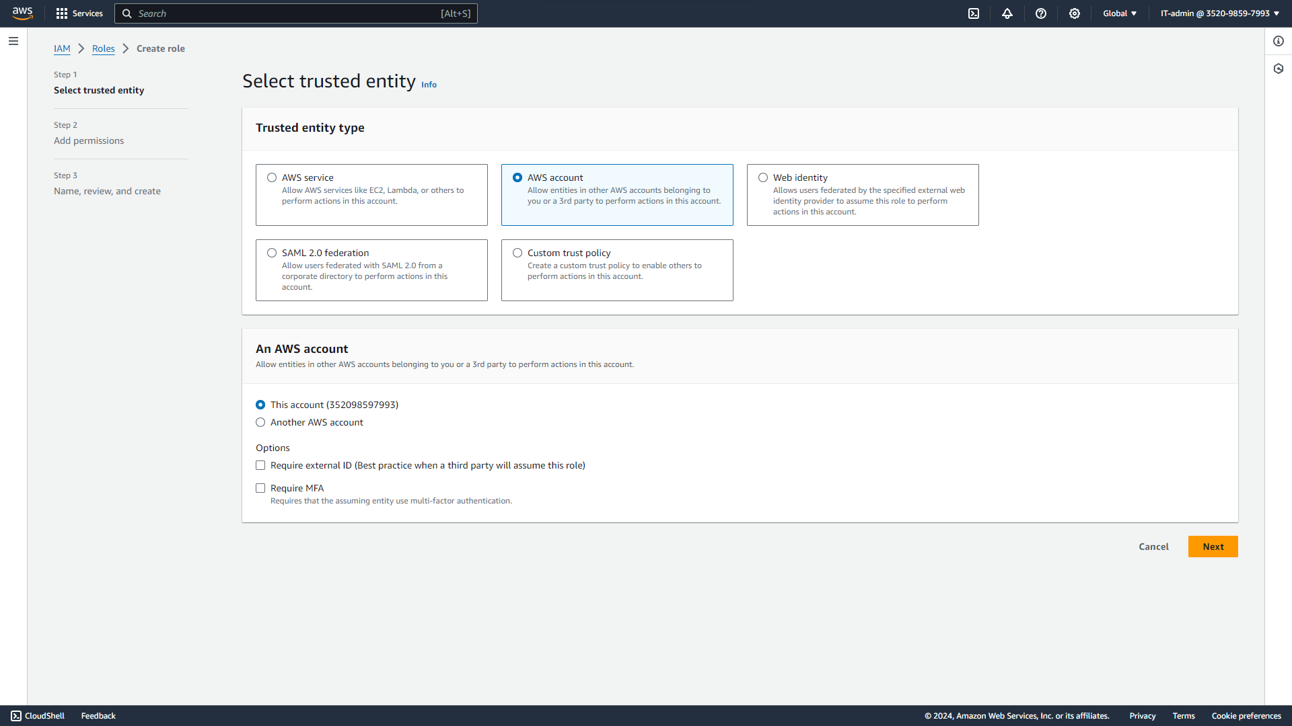

**Select permission policy-Administrator access and click on next**

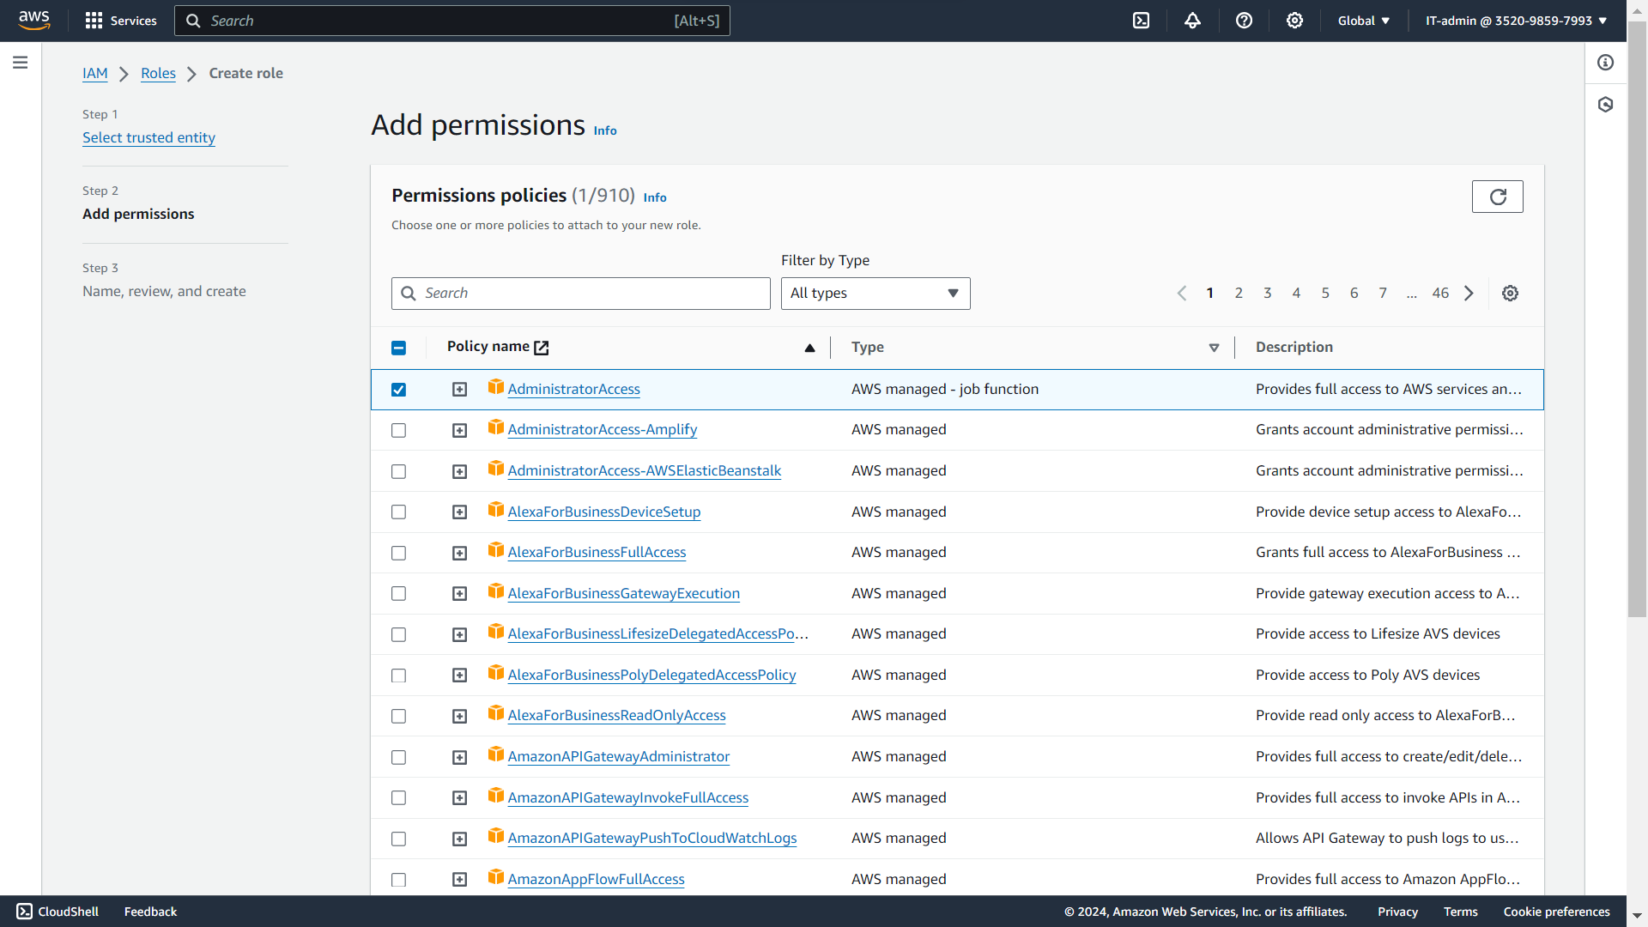

**Give Role name-IT-admin-Role and click on create role**

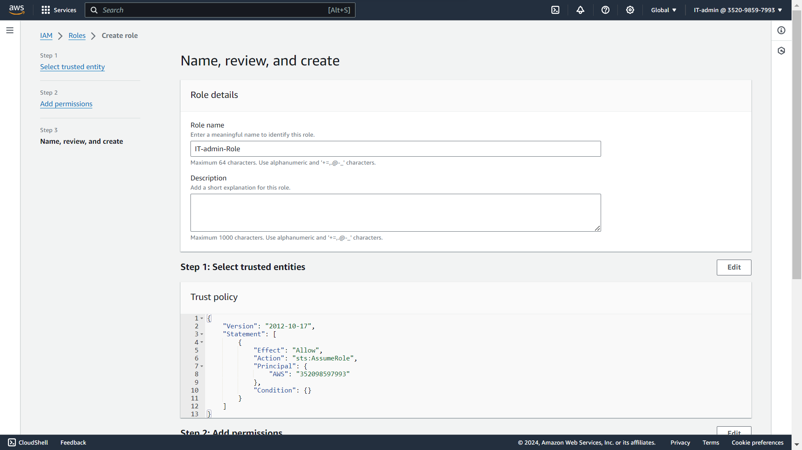

**The IT-admin-Role created**

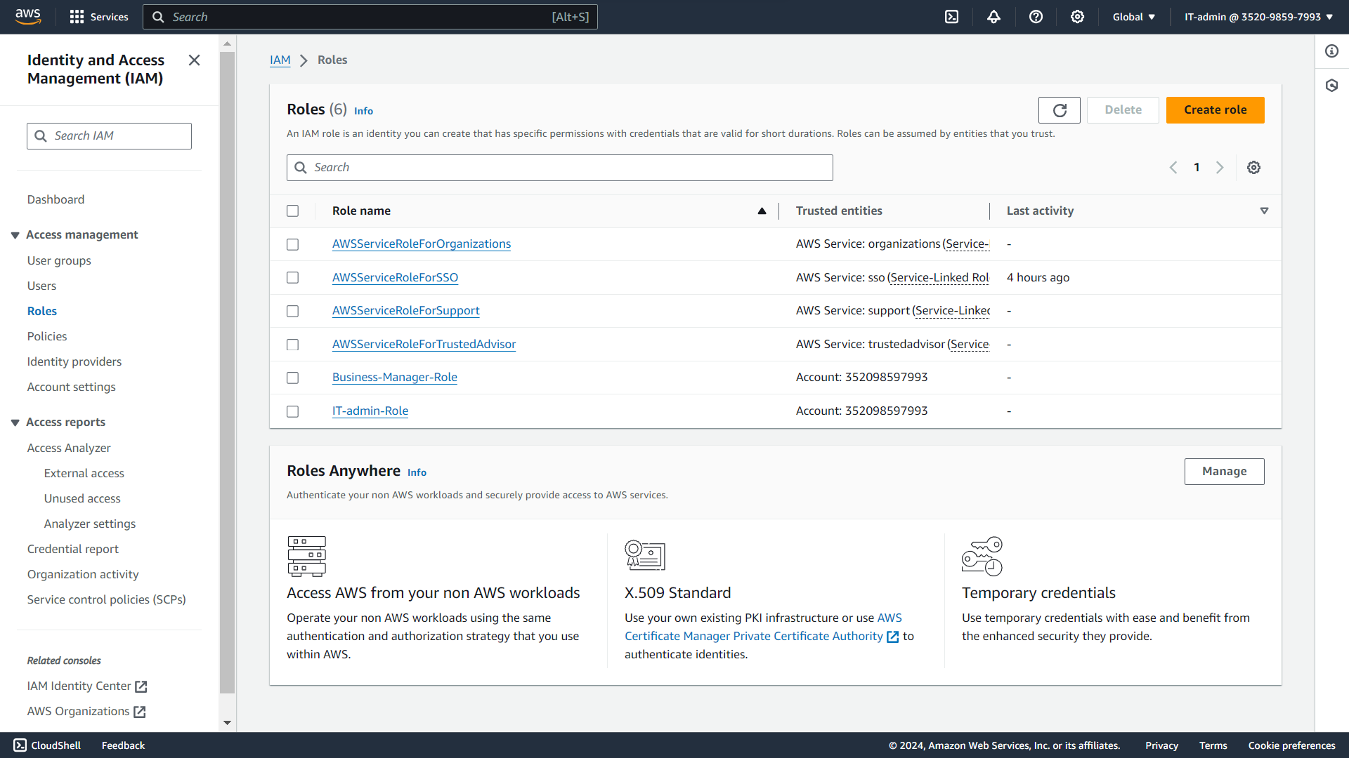

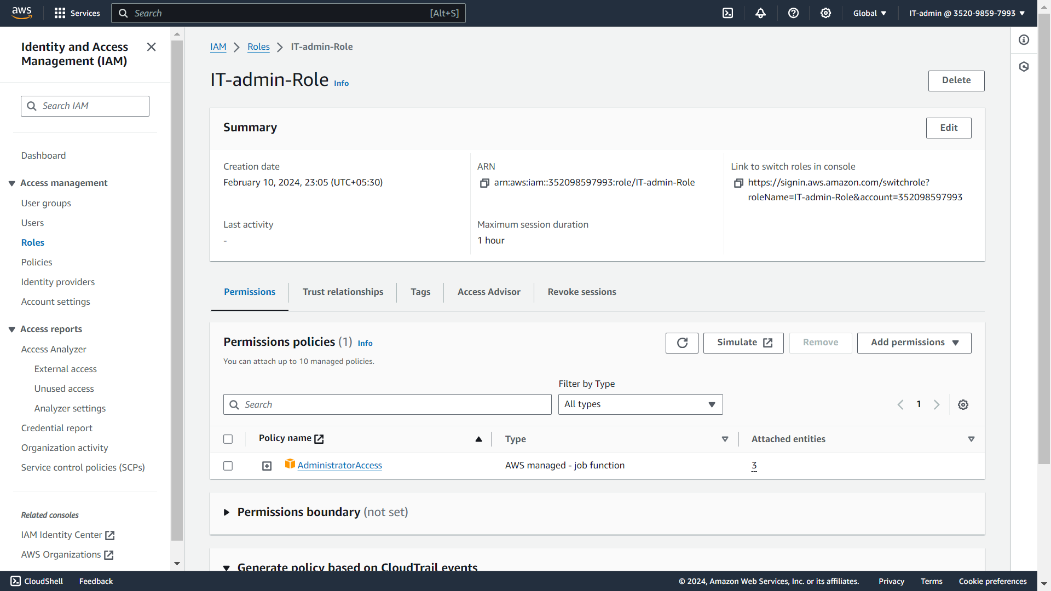

**Go to AWS console and click on IAM user and login with the 2st IAM user-Billing-Manager   
User name and password**

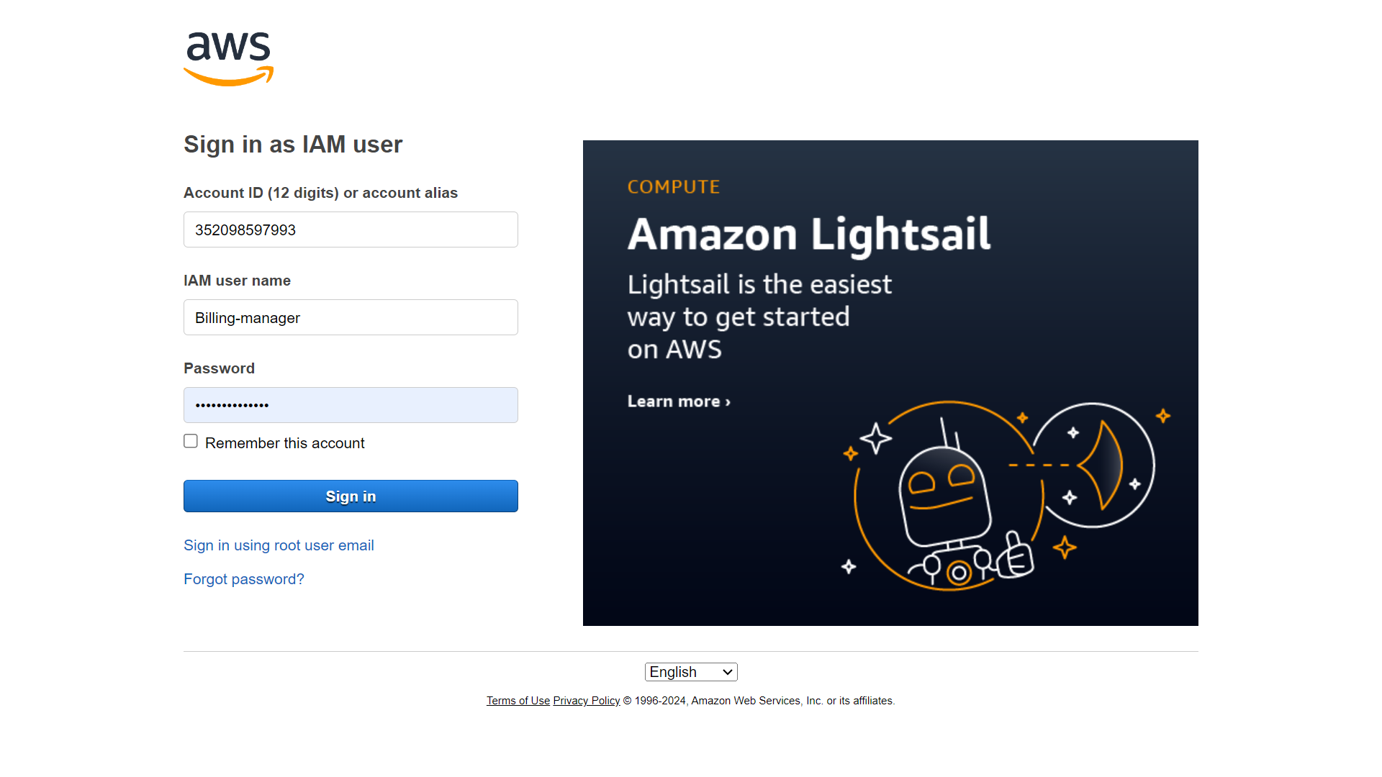

**Select AWS account and click next**

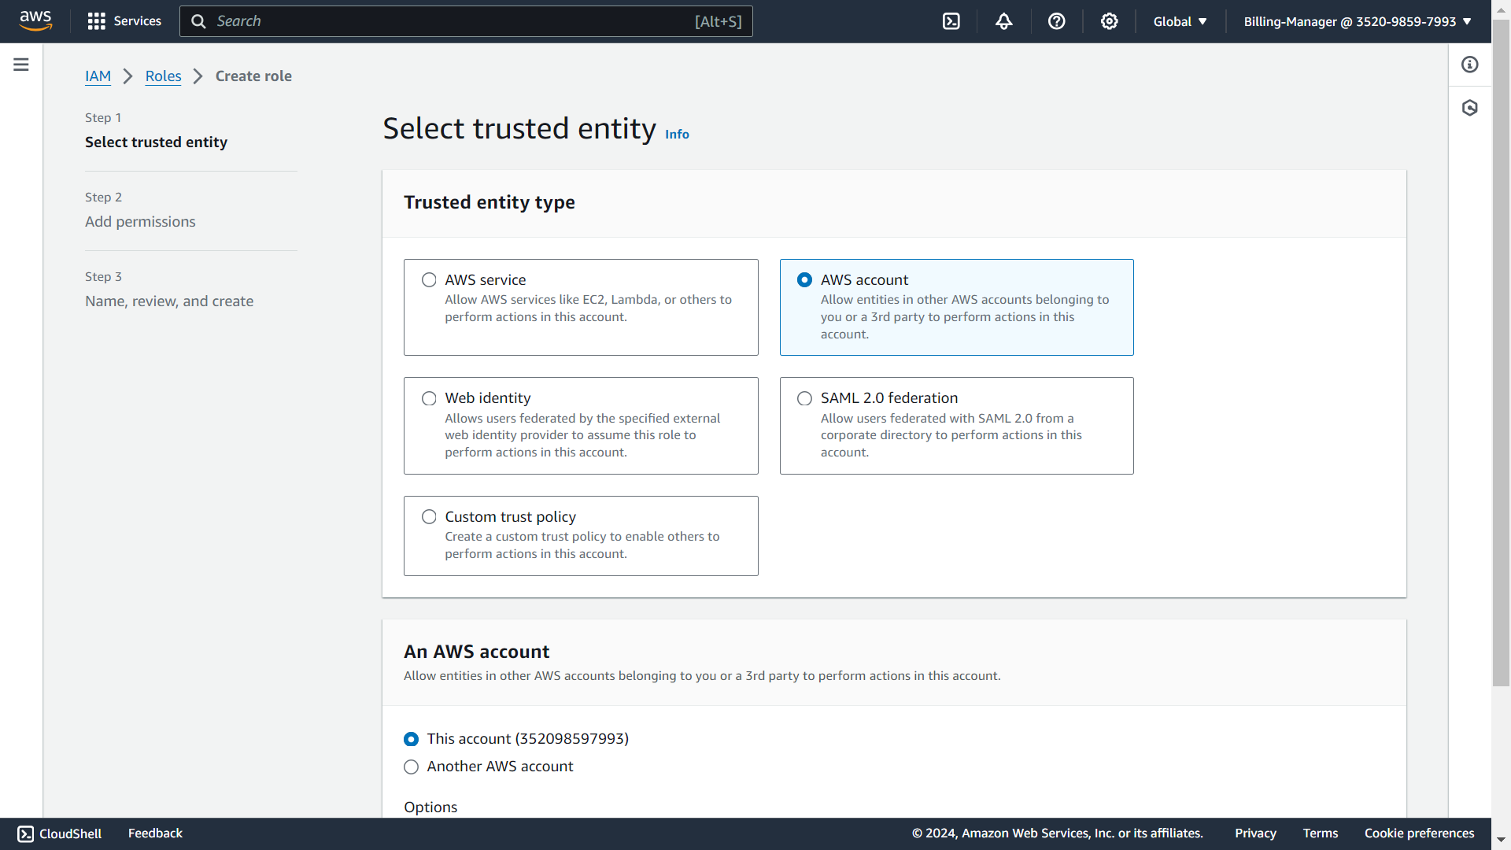

**Select permission policy-Billing and click on next**

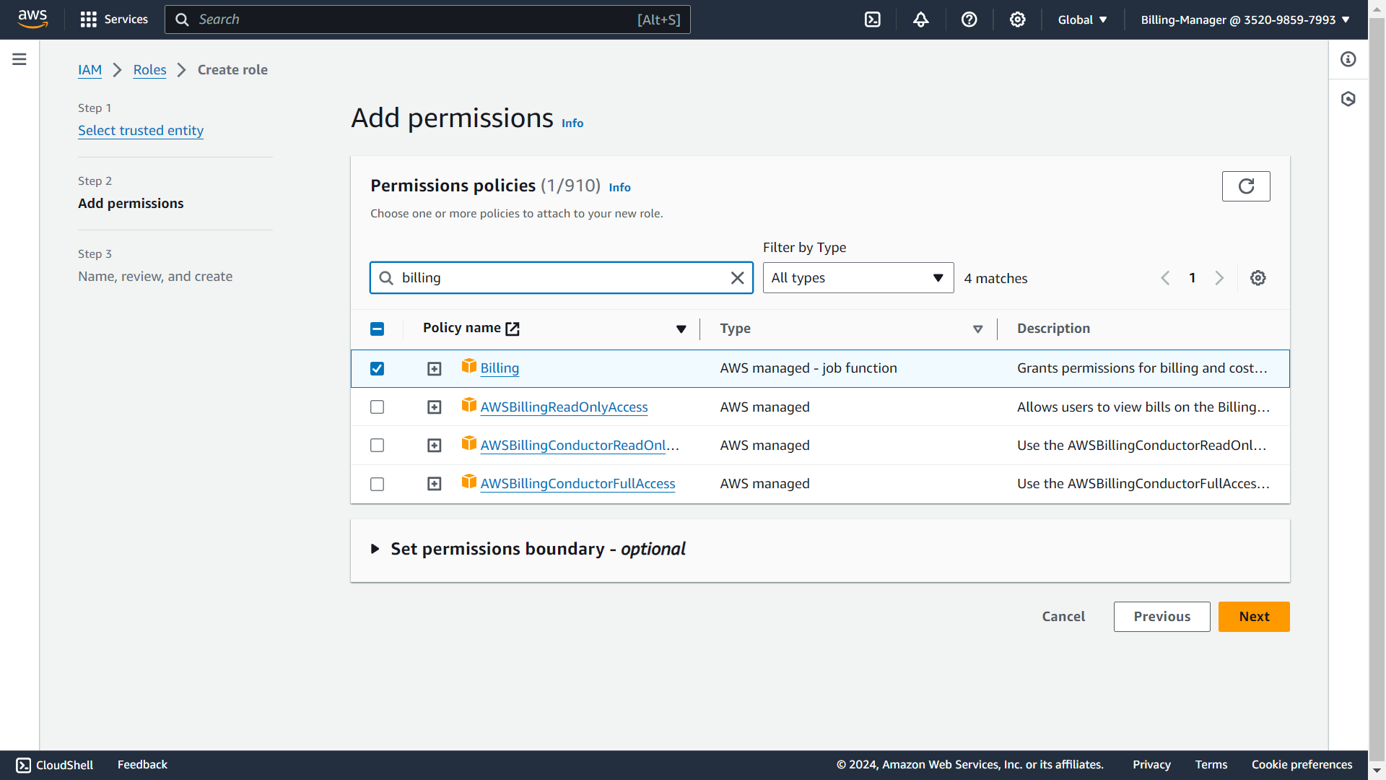

**Give Role name-Billing-Manager-Role and click on create role**

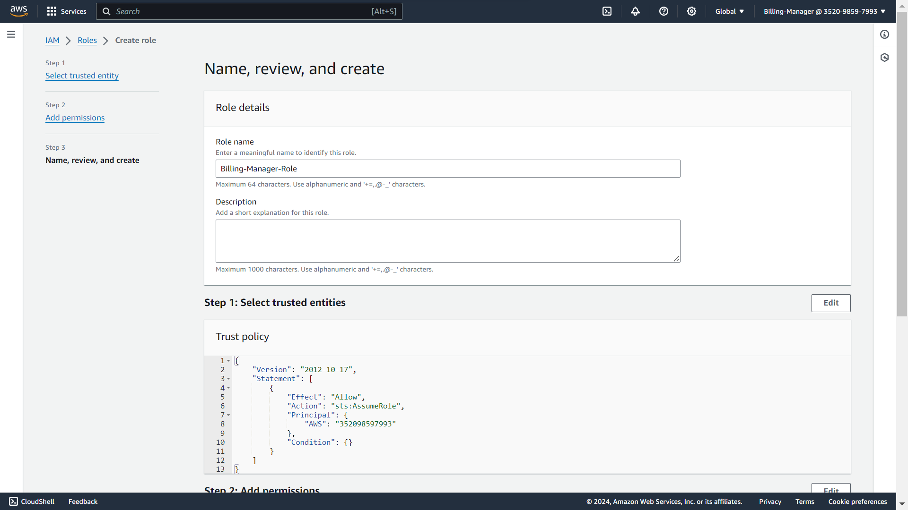

**The Billing-Manager-Role created**  
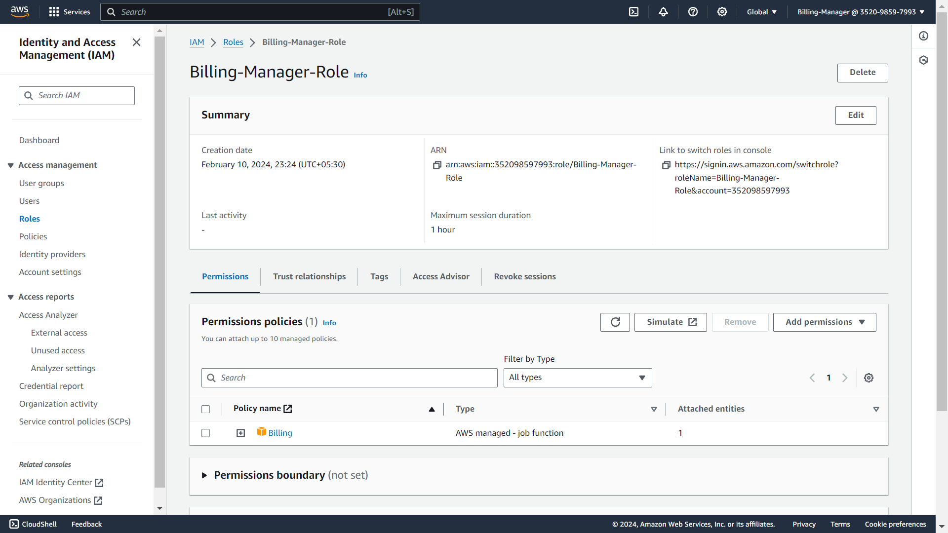

**These are the created roles**

